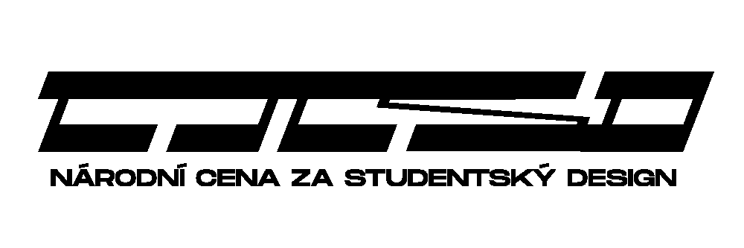
CZECH INTERNATIONAL AWARD FOR STUDENT DESIGN 2019
A Brief Guide to the Registration of the Work (Frequently Asked Questions)

What Kinds of Works Can Be Submitted?

Any works that can be included in the domain of product and industrial design – product design (for example, interior and outdoor furniture, interior accessories, glass, pottery, lamps, tableware, cookware, sanitary ware, toys, sports equipment, wrappers with putting emphasis on their construction, musical instruments, teaching aids, hobby etc), industrial design (i.e. design related to construction of tools, medical technology, transport design, mechanical engineering, agricultural technology, civil engineering, building construction etc), applied arts, arts and crafts or art design (textile and clothing design, footwear, accessories, jewel, and various author´s designs), architecture, design of private and public interiors, stage design, and landscape design created after January 1, 2016 and which had not been enrolled in any of the foregoing years of the National Award for Student Design can be submitted to the National Award for Student Design 2019.

The students of Universities, High and Professional Schools who finished their studies in summer semester 2019 at the latest may take part in the competition. Both Czech and foreign student works are acceptable.

What Do You Need?

You must prepare these materials before registration your work (no info that could identify the author must be introduced; there are two exceptions: names of image attachments and the name of the file with poster!):

- Electronic form of the presentation panel (poster); JPG, the length of the longer side of the poster 2500-3000 px, resolution 300 dpi, maximal size of the file 15MB; format of the file name (only accepted characters are A-Z, a-z, 0-9 and “underscore” _, no spaces or diacritics):
surname_name_PO.jpg
- Maximal number of visual enclosures is 8; JPG, the length of the longer side min. 1500 and max. 3000px; format of the file name (only accepted characters are A-Z, a-z, 0-9 and “underscore” _, no spaces or diacritics):
surname_name_01.jpg
surname_name_02.jpg
- Name of the work and subtitle (also in English) and short annotation (extent cca 300 – 1500 characters) and English translation of the annotation.
- If the work is physical object, provide info about dimensions, weight (brutto + netto) and about used materials.
- If you are submitting your work through your school, check up whether (and in what way) the school will participate completely or partially on paying the registration fee.

How to Submit Your Work?

Connect to the web pages on www.studentskydesign.cz before June 26, 2019 and fill-in all necessary items. If you need next info, please contact us via e-mail
(info@designcabinet.cz) or by phone + 420 733 155 985.

What to Do Next?

You will be informed by e-mail from the Foundation SUTNAR – FOUNDATION OF RADOSLAV AND ELAINE SUTNAR about next steps (paying registration fee, assigning registration number, alternatively about advancing to the national round and delivering your works and printed posters).

Important Deadlines and Dates

- June 26, 2019: closing of the registration form – up to this day it is possible to edit both applications and attachments (in case of necessity it is possible after agreement to prolong the term to June 30, 2019)
- September 5, 2019: suppose date of session of the International Jury
- November 11, 2019 exhibition of awarded and selected nominated works New G(o)ods 2019! in the DEPO2015 in Pilsen
- November 14, 2019: announcement of the results of the competition in the DEPO2015 in Pilsen
- December 2019: Exhibition New G(o)ods 2019! in the gallery of Faculty of Architecture of ČVUT in Prague.

