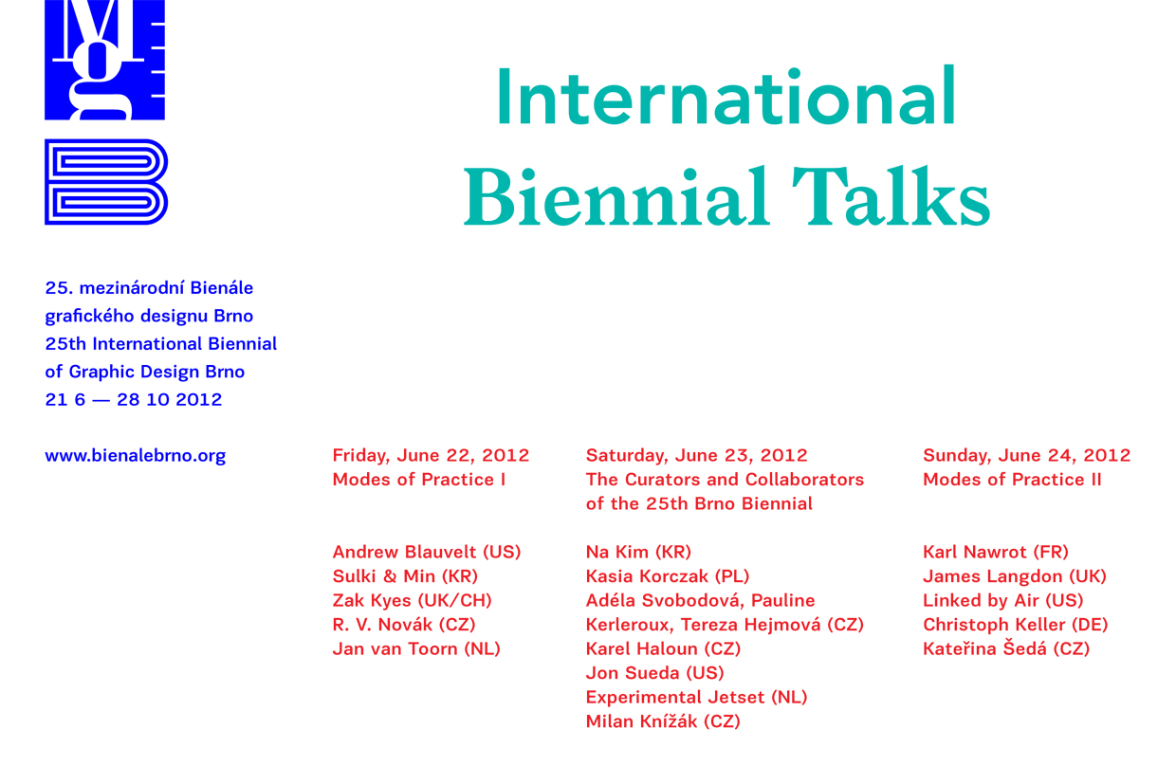

Application form

I hereby register for participation in the International Biennial Talks – Modes of Practice
organized as part of the 25 International Biennial of Graphic Design Brno 2012.

Name and surname:
Home address:
Telephone:
E-mail:
A / regular participant
B / student
C / invited guest, journalist
Date:

Registration address: miroslava.pluhackova@moravska-galerie.cz
Deadline: 15 / 5 / 2012

