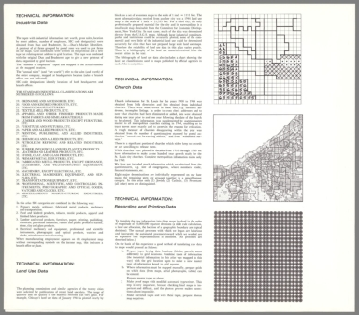
Urban Atlas: 20 American Cities

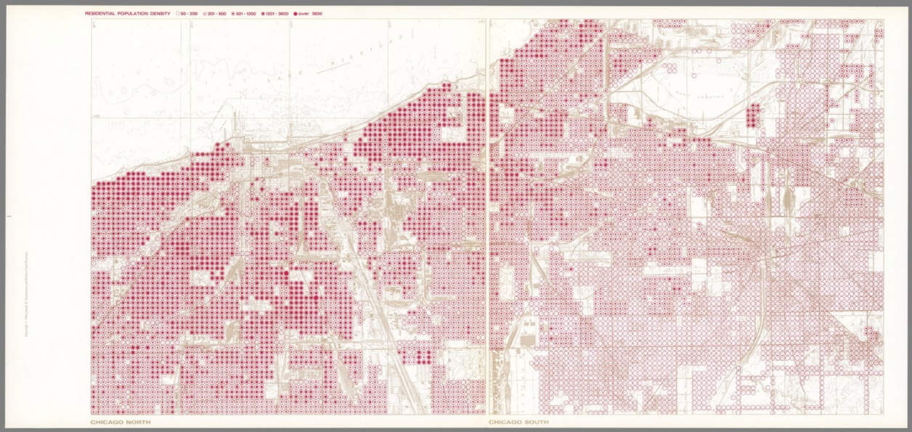
Chicago North; Chicago South. Residential Population Density. 1966, City Atlas

