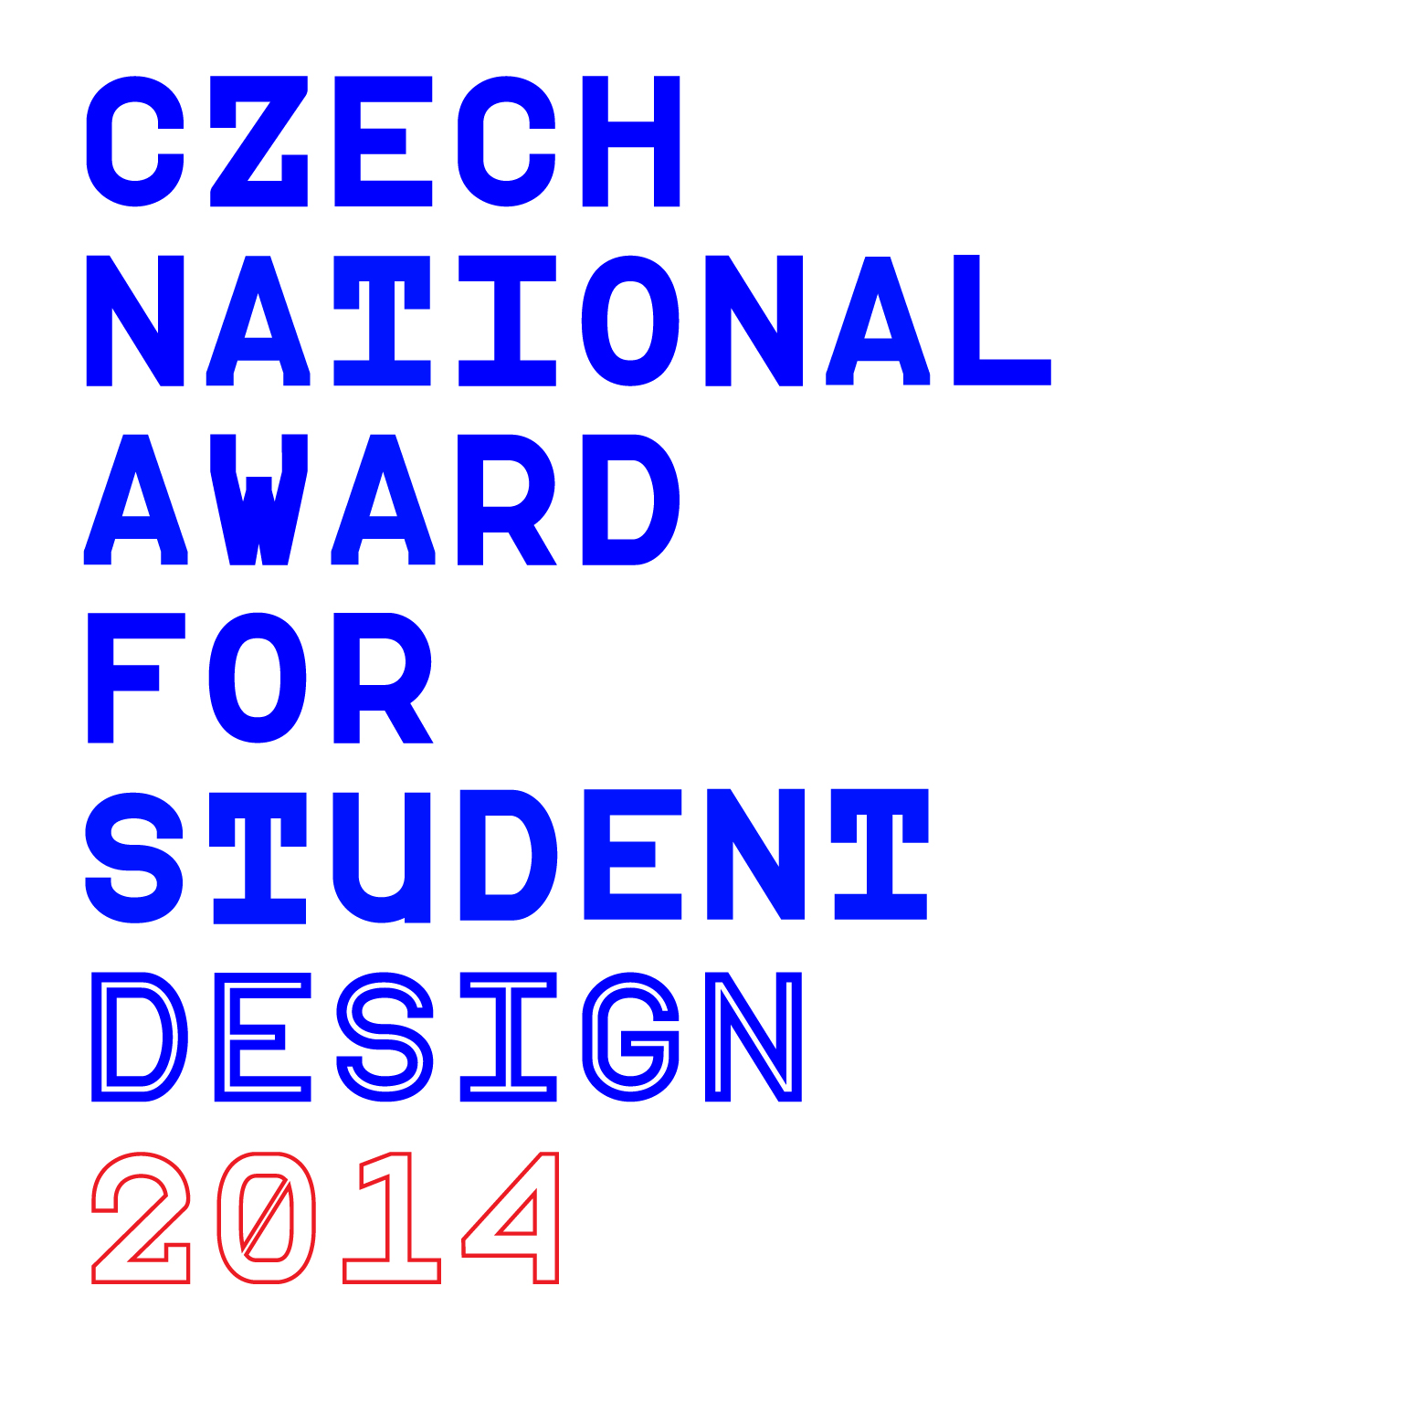
CZECH NATIONAL AWARD FOR STUDENT DESIGN 2014
Conditions of the Competition
Design Cabinet CZ in cooperation with Architecture & Building Foundation, The Moravian Gallery in Brno, Slovak Design Center, Union of Professional Designers CR, Association of Applied Graphics and Graphic Design, Syndicate of Artists, Czech Union of Graphic Design, and participating Universities announce the competition for the Czech National Award for Student Design 2014.
Competition is established for Universities, High Schools, and Professional Schools of design, architecture, handicraft, and fine art in Czech Republic and abroad.

Aim of the Competition, Participants, and Subject of the Competition 2014

Aim of the Competition
The aim of the competition is finding a connection & cooperation between schools, students and business and a permanent monitoring, documenting, evaluating, and presenting of student works of design, architecture, arts and crafts, and fine art.

Participants of the Competition
Students of Universities, High Schools, and Professional Schools can participate in the competition, if they finished their studies at the latest in the summer semester 2014. Both individuals and author teams from Czech Republic or abroad can participate in the competition.

Subject of the Competition 2014
- Kind and Time Specification.
All student works i.e. final exam, semester, graduate and other own works in the field of design, architecture, arts and crafts, fine art, and visual communication that were created after January 1, 2012, but had not been registered in the previous years of the competition, are acceptable.
- Topic Specification.
All works from the widest spectrum of the term visual communication - e.g. graphic design (posters, books, booklets, visual styles, typography, experimental graphic design, interdisciplinary graphic design etc.) applied and advertising photography related to the design, graffiti, digital media, motion design etc.
- Requirements.
The requirements are described in the Appendix 1. The registered works that do not satisfy the specifications defined in the paragraph 1 of the Conditions or do not satisfy the specifications defined in the Appendix 1, will not be accepted.
If the registration fee is not paid in the defined term then the work will be put out (see the paragraph 3.2 of the Conditions).

Juries, Way of Assessment the Accepted Works, and Awarding

Juries
Three independent juries (named by the director of Design Cabinet CZ with consideration of announcers) will assess the accepted works.
The High School Jury will consist of appointed High School teachers and professional designers or artists. The University Jury will consist of appointed University pedagogues and professional designers or artists. The National Jury will consist of independent experts, curators, and professional designers or artists. The Juries may be international.
Jury members will be appointed in cooperation of individual educational institutions and organizers of the competition.
The High School and the University juries will be assembled on these principles:
- A pedagogue may become a member of jury if at least two works from his/her atelier were accepted and the school confirmed his/her appointment.
- Some members of juries are pedagogues whose students were awarded in the last year's competition (National Award, Excellent Design or Good Design).
- Some members of juries are pedagogues from the directly cooperating schools (Art and Design Faculty of the J. E. Purkyně University in Ústí nad Labem, Ladislav Sutnar’s Art and Design Faculty of the West Bohemian University in Plzeň, Faculty of Mechanical Engineering Brno University of Technology).
- In case when the constitution of jury does not correspond to the set of branches of accepted works, then a next member will be appointed along results of the last year's competition.
Composition and results of the National Jury will be published in a separate document.
Schools will be called upon to taking part in juries by Director of Design Cabinet CZ. Each addressed educational institution will make a proposal of jurors and their deputies with consideration to the recommendations of Design Cabinet CZ Director.
Constitution of the juries will be published on www.designcabinet.cz, www.studentskydesign.cz, on web pages of the cooperating announcers and on the web pages of the schools and universities that will show interest in it.
The membership in the Juries is honorary.

Way of Assessment for Universities, Schools, and Professional Schools
Assessment of the works will be performed via internet.
Design Cabinet CZ will provide the appointed jurors with all the necessary materials (photos, videos, animations, annotations etc. in digital form), table with the list of the accepted works, criteria for assessment, assessment point scale, and tables for assessment.
Each juror will assess each work individually by recording points into the table along defined criteria.
The assessed works will be anonymous, i.e. the jurors will know only registration number without knowing names or schools.
Director of Design Cabinet CZ nominates the secretary of jury and the deputy to secretary. The secretary will process the completed assessment tables and on the base of number of points from all jurors then will decide which works will be nominated for National Award for Student Design. In the case when there is not a clear level for definition of nomination, new materials will be sent to jurors for next round of assessment.
The secretary and the deputy are responsible for organization of assessment, communication with jurors, maintaining running documentation, and working out of the final report.
Members of the both University and High School juries will have at least 10 days for the assessment of works.
All registered and accepted works will be assessed.
Point assessment of the works will be registered.
Any juror may help with evaluating of assessment tables and check the results when assessing is finished.
Criterions for assessment will be published later and will be available for the members of all three juries well beforehand.

Nominations and Advancement to the Final National Round of the Competition
Both the University and High School Juries decide on dependency on the point assessment about nominations for the National Award for Student Design 2014. The independent National Jury consisting of professional designers and experts (respected personalities out of educational institutions) will award at most 10 prizes on the level of Good Design, 10 prizes on the level of Excellent Design and one National Award for Student Design 2014 (unless the National Jury issues other decision).
All nominated works may be awarded special prizes by cooperating announcers or partner organizations.

Funding of the Competition and Registration Fee

Way of Funding
The competition is based on funding from more sources. Even in 2014, the key is the registration fee that presents the participation of schools or students who registered individually. The main finance source is contributions of private donors.
The account was opened at ČSOB, a.s. belonging to the Architecture & Building Foundation.
Account Holder: Nadace pro rozvoj architektury a stavitelstvi
Bank Name: ČSOB, a.s.
Account Number: 254397167/0300
IBAN: CZ9003000000000254397167
BIC: BEKOCZPP
Payment Purpose: assigned registration number (will be sent by e-mail)
or
Transaction Number: assigned registration number (will be sent by e-mail)
The registration fee must be paid to this account.

Registration Fee
Registration fee is CZK 1000 (VAT included) per each submitted application.
Registration number will be assigned to each registered application (see the Payment Purpose or Transaction Number).
Account Holder: Nadace pro rozvoj architektury a stavitelstvi
Bank Name: ČSOB, a.s.
Account Number: 254397167/0300
IBAN: CZ9003000000000254397167
BIC: BEKOCZPP
Payment Purpose: assigned registration number (will be sent by e-mail)
or
Transaction Number: assigned registration number (will be sent by e-mail)
Due date is 14 days after issuing the invoice (and assigning the registration number).
If the registration fee is not paid in term, then the application will be put out of the competition.
The registration fee serves for covering the administrative and organizational costs of the competition.

Deadlines for Submitting Applications and Providing Works for the Competition

Applications
The deadline for submitting the applications (i.e. registration) is June 25, 2014. The completely filled-in application form must be submitted (all image attachments included) on the address www.studentskydesign.cz/en. Design Cabinet CZ assigns to each registered work unique registration number. The accepted works are assessed anonymously only under their registration numbers.

Competing Materials and Enclosures
All necessary enclosures that are part of the application must be registered via application form on the address www.studentskydesign.cz/en ; the deadline is June 25, 2014 (see the previous paragraph). Exceptionally and due to well-founded cases, extra term may be arranged for some schools after agreement with the school leadership. The schools will be informed about extra term via rectors, deans or heads of departments and ateliers.

Collecting of the Nominated Works for Evaluation by the National Jury
The date and the place of collecting of the nominated works will be published at the end of August on web sites www.studentskydesign.cz and www.designcabinet.cz.
Posters (size 70 x 100 cm on the solid kappa undercoat) will be presented to the National Jury together with the nominated works.
No works collected for assessment by the National Jury are insured.
Some participants of the competition can be asked to provide posters and works for exhibitions abroad.

Giving Back the Materials
The posters and the nominated works will be given back to the participants of the competition after appeal of the Design Cabinet CZ. If the materials are not withdrawn during one month, then they will be provided to the collections in museums engaged in design.

Announcement of the Results and Ways of Presentation

Announcement of the Results and Awarding
- Announcement of the Results
Announcement of the results is supposed on November 11, 2014. Nevertheless, Design Cabinet CZ reserves the right to change the date and place. This change will be announced in time. Letter of invitation for the ceremonial awarding will be sent to all the participants.
- Press Conference
Design Cabinet CZ will arrange a press conference on November 11, 2014 at 11:11 AM where reporters will be given press materials, CD/DVD with visual data etc. All awarded students, their pedagogues or school representatives will be invited to take part in the press conference.
- Media Campaign
Design Cabinet CZ will organize media campaign in two waves. One month and one week before awarding.

Presentation of the Competition
Presentation of the results and awarded works will depend on the amount of financial contributions of private subjects. Exhibition of the works nominated for National Award for Student Design will be held in The Moravian Gallery in Brno from September 19 to October 26, 2014 as a part of Biennial of Graphic Design Brno.
Exhibition of awarded works New G(o)ods! will take place in the gallery Era World in Prague. from November 6, 2014. It is supposed that the results of the competition will be presented both in Czech Republic and abroad via Czech Centers in years 2014 and 2015.

Presentation of the Registered Works
An adequate documentation will be prepared to the exhibition in which all awarded works will be presented and also all registered works and the schools where these works were created.
Each participant of the competition (student) will receive free of charge one presentation product and each registered school will be given some presentation products related to the number of registered works (relation will be approximately 1:5).
The results of competition will be also published on Design Cabinet CZ web pages, on Student Design web pages, on web pages of cooperating announcers, on web pages of partners, and on web pages of participating schools and ateliers if they show their interest in it.

Expert Guarantor of the Competition and Contact Address
The competition is organized by the Design Cabinet CZ, Architecture & Building Foundation, and cooperating institutions.
Contact:
Design Cabinet CZ
Architecture & Building Foundation
Vaclavske nam. 31, 110 00 Praha 1
Czech Republic
Tel.:
+420 224 225 001
+420 222 245 647
+420 602 350 805 (PhDr. Lenka Žižková)
+420 732 560 799 (BcA. Pavel Coufalík)
+420 605 230 731 (MgA. Petra Miškejová)
+420 734 587 770 (Viera Postníková)
Fax:
+420 224 233 136
E-mail:
info@designcabinet.cz
zizkova@designcabinet.cz
Web:
www.designcabinet.cz
www.studentskydesign.cz
Appendix 1: Requirements to the Application and Submitted Works
- Competition Applications
The application is submitted by complete filling-in the application form (all image attachments included) on the web page www.studentskydesign.cz/en.
- Competing Works
Competing works are accepted to the competition in the form of appropriate photo-documentation or other visual form that are loaded during filling-in the registration form on the web page www.studentskydesign.cz/en and the format must be corresponding with the technical specifications defined in the web registration form.
Maximal number of the enclosed files with the visual attachments (without poster) is 8. It is necessary due to publication in order that name of each enclosed file has a unique identification (name of author, name of work, alternatively name of author of the photography) or caption to the photos.
No diacritic is allowed in the names of the files (only acceptable characters are A - Z, a - z, 0 - 9, and character “underscore” _). If the requirements on the format are not met, then the work will not be registered. In case of special kinds of presentation (video, animation, etc.), please, contact us via e-mail info@designcabinet.cz.
In case of nomination and advance to the national round, the competitors or schools will be called upon (in the end of August, at the beginning of September) to provide the design:
- As a model, a prototype, or a complete product for assessment by the National Jury (please, see the details about the national round), if it is required by nature of the work.
- As a presentation board (poster) with dimension 70 x 100 cm (on height), on the solid kappa undercoat (max width 0.5 cm); the works adjusted in frames or in glass will not be accepted. The registration number must be written on the reverse side.
The works and all documents must be labeled with the registration number, but no other identification info must be present (especially no name of author or school), otherwise the anonymity of the competition would be violated.
The models (prototypes, products) and the presentation boards will be assessed by the National Jury and will be used for the follow-up exhibitions.
- Enclosures to the Competing Works
- Mandatory Enclosures
See the Appendix 1, item 2.
- Agreement with the Conditions of the Competition
Author (co-authors, school) by filling-in the registration form on web pages www.studentskydesign.cz/en and sending it, expresses (express) consent with the free of charge using of the works for exhibiting and publishing, for publishing the works and contacts on internet, and expresses (express) consent to Design Cabinet CZ for creating photos, videos etc. with full respect to the copyrights.
The participant (school) explicitly agree that the competing work (protected work) may be used by the announcer of the competition (without claiming any reward) for above presented purposes in all ways of use, for all countries of the world, without any time limitation or the competing work may be provided to third persons for the same purposes even after finishing the competition.
The law of the Czech Republic is crucial for all conditions of taking part in the competition, conditions of the competition, and authorization of using the competing works. All persons involved agree that any conflict related to the competition will be solved conciliatory in presence of announcer of the competition. Judge authorities that are relevant for solving possible conflicts (that was not closed conciliatory with cooperation of announcer) are general tribunals of Czech Republic.

